ONLINE LEARNING
Name:
Professor:
Course Title:
Institution:
Date:

Do the empirical education system and methods of learning equip the students for the 21st Century career life? Unlike other centuries the 21st century is peculiar in the way technology has dominated most aspects of life. So indispensable has the use of technology in daily lives, careers and social operations become, that it is only prudent to think of ways to incorporate it in life and appreciate the change. As per the most recent survey conducted by Babson Survey Research Group, more than 30 percent of higher education students in the United States is taking at least one distance course. It is irrefutable that online learning meets the needs of millennials. Governor Bob Wise (2010) stated that “ K-12 education in the United States is ―dealing with three major crises: global skill demands vs. educational attainment; the funding cliff; and a looming teacher shortage” (p. 2).
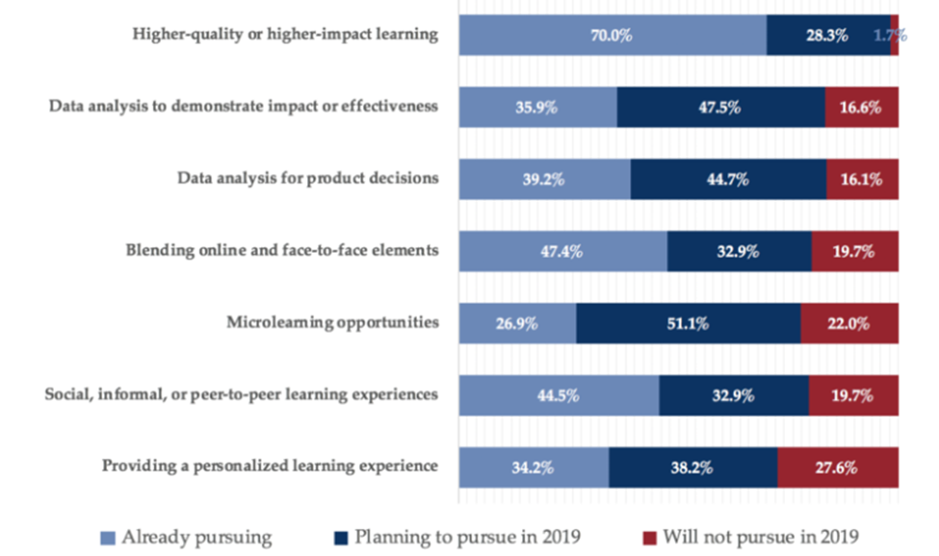
Some learning institutions in California such as University of California College Prep Online (UCCP) provides online Advanced Placement (AP), college preparatory as well as offer recovery courses to students across the state many of whom would otherwise not have access to these courses due to a lack of qualified teachers in all subject areas and/or small school size. Another university-based online program, Stanford's Education Program for Gifted Youth, offers courses to students in 28 countries. Besides the University of California, Chicago, and Detroit to mention but a few have adopted this new way of learning. However, educational leaders have been forced to work in uncertain times since they are yet to be sure if the education offer will support the students enough to thrive in the techno-era. The ongoing COVID-19 pandemic has increased more questions on the empirical way of learning with over 1.5 billion students learning remotely. If online learning is essential, then what stands on the way to its implementation? There must be opposition and challenges that deter the adoption of online learning.
Are learning institutions and students in California well equipped for the total adoption of online learning? Generally, the Californian education system is not fully equipped for the total implementation of online learning. This problem is however more pressing in the rural set-ups. This challenge comes as a result of difficulties in changing the traditional learning system and structures online and coming up with a funding system that accommodates both the online and brick-and-mortar learning. While this, not a change that can be adopted once some districts are already doing this for the benefits to the students and the fact that it reduces the pressure of enrollment in other districts, charter schools. The schools that took part in the AB 294 pilot program assessed the costs of online courses and they all stated that the difference in cost with comparison to traditional learning is insignificant. Additionally, many of the online students are either funded through via independent study, while others receive ADA funding via the AB 294 Online Classroom Pilot Program. Oblivious of the interplay of legal, policy, funding, and the fact that most districts lack the expertise to support the learning, the transition is quite fast. This shows that the structural and financial challenge facing online education is one that can be addressed.
According to David Bleich(1995, pg.572), "computers symbolize the rigidities of pure logic" and they domineer the structural decision and planning processes. He also posits that artificial intelligence that is currently being equated to human intelligence through the utilization of cognitive science idealizes the purity of thought in logic. This is in line with other critics and arguments about online learning point out the separation of feeling and passion from learning. On a broader scope, it will be argued that online learning takes way the in collaborative, interpersonal, and collective elements in learning which are considered integral for the success of a student. Does online learning deemphasize emotion or the pathic domain? While this could have some truth, it cannot supersede the essence of online learning since neither the student nor the teacher gets instant feedback from nonverbal hints about each other's emotional state. Most course designs focus on delivery using logic. The curriculum in online learning is defined by logical planning and tools in which information is disseminated to students. On matters content, the learning process meets the logical requirement of any human learning process. The ethos of online learning can be evaluated on the student-instructor engagement. Currently, total credibility may not be accorded to online learning but it is possible to measure and enhance the content being delivered. Assessing online learning from a perspective that is not "self' centered, without focusing on classroom dynamics, it is easy to evaluate the participation inhibitors. From this dimension, online learning allows instructors and learners to respond to each other besides responding to other multiple complex identities.
Online learning allows a continuous learning system, one that is not interfered with by geographical factors. Online education enables students to learn without having to commute or follow a rigid routine. While some administrators ask whether students will be diligent enough to follow through, it is important to see the value that this new pedagogy instills in students: a sense of responsibility and working under minimal supervision. Most companies today have adopted remote working, thanks to technology and their productivity has remained high still. With commuting are numerous expenses and the virtual classroom is slowly allowing directing these resources elsewhere. Also, it offers an opportunity to engage in other productive activities like part-time jobs.
As the nature of work changes – more project-based work, flattened organizational structures, new human: technology relationships, more global networks, and supply chains – then the need for skills development and learning "on the job" becomes clear. Given the expectation that these developments will each accelerate and impact between 30-40% of all jobs, then constant learning becomes a driver for any time, anywhere learning (Schwirzke, 2011). Now that the pandemic has disrupted the global economy – the IMF predicts a 5% fall in global GDP with some industries disrupted for many years to come (e.g. hospitality and tourism, travel, banking and financial services, retail) and high unemployment for some time to come – upskilling and reskilling will become a strong focus for government investment in higher education. Already, micro-credentials are being seen as a response to this challenge. Work will change significantly over the coming decade. Recent innovations and developments in flexible, competency-based learning and assessment will give new impetus to online learning and work-related skill development.
A good learning system is one that is learner-based. Online learning allows students to access a wide variety of learning material for free. Additionally, a good learning system allows exploration and appreciation of various worlds, and the internet offers an opportunity to access multiple sources of knowledge. It gives the discretion to the student to choose interpretations of different learning aspects and build interests in the areas that they feel most comfortable. Learning has become more engaging since students can use smartphones and video cameras to collect actual data which actively involves them in research and understanding the logic behind some of the concepts that they learn in class.
Additionally, students in any single class will have different needs. Within the framework of the online learning objectives, more flexible approaches to content choice, delivery, assessment, and other factors are emerging(Levy,2003). Equally important is educating students to take responsibility for their learning and approach this as a skill to be taught and learned. The online learning approach challenges the tutors to shift from selecting and transmitting information in large blocks or chunks, such as a one-hour lecture or providing a single textbook, to guiding students to find, analyze, evaluate, and apply information relevant to a particular subject domain. This 'relevance' becomes more negotiated between the instructor and student. Indeed, the term 'instructor' becomes misleading in this context, as the role moves more to that of facilitator with less control over where and how learning takes place, and often entering into negotiation over exactly what the content is.
Besides the student needs, the corporate, social, and cultural environment today calls for better learning systems. Systems that only equip students with knowledge but also skills applicable in the practical sense of doing things. There are challenges in adopting the online learning system but from the pilot program, transferring efforts and funding from the traditional learning system to online learning will ease the process. In nutshell, it is time to embrace online learning as a necessary way of learning and not a supplementary form.

References
Schwirzke, K.L., 2011. Online learning in California K-12 schools: Status and perceptions of administrators (Doctoral dissertation, Argosy University/Phoenix).
Levy, S. and Beaulieu, R., 2003. Online distance learning among the California community colleges: Looking at the planning and implementation. The American Journal of Distance Education, 17(4), pp.207-220.
Bleich, D., 1995. Collaboration and the pedagogy of disclosure. College English, 57(1), pp.43-61.
Wise, B., 2010. The online learning imperative: A solution to three looming crises in education. The Education Digest, 76(3), p.52.

